This chapter will teach you the possible power of generative AI as well as how AWS offers a solid platform to leverage its full potential. To start with, you will explore the multi-layered AWS generative AI Stack offering that empowers you to create scalable and efficient AI solutions. Then, you will drive deep further into possible industrial use cases, highlighting its influence in retail, banking, finance, healthcare, and other industries.

Next, you will explore Why generative AI on AWS, highlighting the platform’s unparalleled advantages, including flexibility, cost-efficiency, and global reach. Moving forward, you will cover strategies for accelerating generative AI application development on AWS, offering insights into tools like Amazon Bedrock and Amazon SageMaker that streamline the entire development process.  
Finally, you will walk through the generative AI project life cycle, examining critical phases such as use case definition, data strategy, model selection, evaluation, deployment, and monitoring. By the end of this section, you will have a comprehensive understanding of how AWS enables enterprises to accelerate their generative AI journey, unlocking new opportunities for innovation and growth.

# **2.1 AWS Generative AI Stack**

You can observe the rapid innovation in generative AI happening in the industry. Even enterprises want to adapt and accelerate to get benefits to solve their business use cases across industries. But enterprises are struggling to keep up with it. Most of the customers are conducting multiple experiments with various generative AI providers, but integrating these solutions within their existing products is always challenging for them. Even integrating into their operations is also challenging due to governance, security, and logistical concerns.

Large enterprises often prefer providers like Amazon Web Services (AWS) due to reliability, maturity, and familiarity. AWS is responding to this industry demand by continuously innovating in the generating AI space by offering a simplified multi-layered generating AI stack consisting of infrastructure, tools for building generating AI applications, and pre-built generative AI-based applications. AWS emphasizes its commitment to providing purpose-built services, solutions, and guardrails tailored to the specific needs of each user instead of one-size-fits-all approaches. This makes it the one platform that is being transformed into one of the global leaders by innovation, commitment, and inclusivity combined with enterprise-grade security and privacy.

This will come under three layers that make up the AWS Generative AI Stack. All these layers are equally important to accelerate the generative AI journey for customers based on the use cases they want to solve and the user persona they want to address. AWS is investing in all three layers to help customers accelerate their innovation.

* Top layer of the stack: applications that leverage LLM’s and other FMs
* Middle layer of the stack: Tools to build with LLM’s and other FMs
* Bottom layer of the stack: Infrastructure for FM Training & Inferences

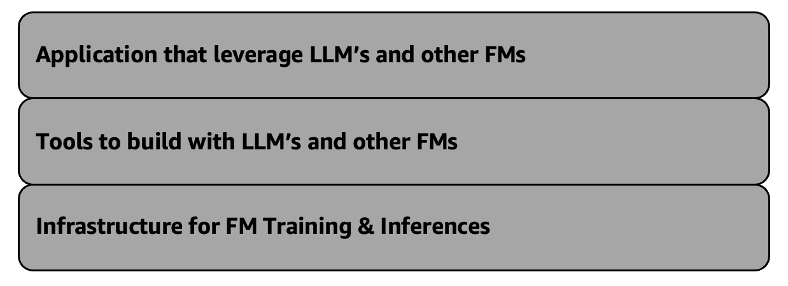

*Figure 2-1 AWS Generative AI Stack*

You will look at the bottom layer and upper layer in the below section. On the other hand, you will drive deep into the middle layer throughout the book. ( Refer AWS Generative AI Stack <https://aws.amazon.com/blogs/machine-learning/welcome-to-a-new-era-of-building-in-the-cloud-with-generative-ai-on-aws/> )

##### **Bottom layer of the stack: Infrastructure for FM Training & Inferences**

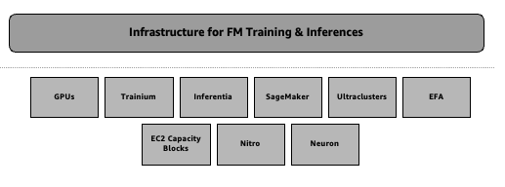

*Figure 2.2 – Bottom layer of the stack: Infrastructure for FM training & inferences*

Amazon Web Services (AWS) has remained at the forefront in terms of innovation in the domain of machine learning and artificial intelligence since the inception of Amazon. AWS continues to invest in ensuring that it offers the most advanced and accessible cloud-based infrastructure capable of supporting future large-scale AI models and applications, providing specialized hardware to high-tech software tools.

The core of AWS’s ML ecosystem incorporates some essential innovations, empowering clients to broaden their AI and ML initiatives beyond limits. These include potent GPU-powered cloud instances (virtual machines), purposefully built silicon-accelerated chips for ML inference and training, a fully managed service known as Amazon SageMaker for building, training, and deploying any ML models, hyperscale GPU clusters, as well as Elastic Fabric Adapter (EFA), which is a unique proprietary high-performance networking technology. In addition, innovative consumption models such as EC2 capacity blocks have been introduced by AWS to ensure customers can get access to necessary GPU resources for their large-scale ML projects based on their needs to get the best price performances. The AWS Nitro System underlies all these advancements; it is a custom-built virtualization technology aimed at delivering industry-leading performance along with cost-efficiency.

The Amazon Neuron SDK connects these hardware and software advances, enabling the customers to enjoy the high-performance capabilities of AWS’s built-for ML Trainium and Inferentia chips without interruption. By simply incorporating Neuron in their existing pipelines, which support most machine learning models, customers can witness substantial enhancements in performance as well as reductions in expenses.

By means of such revolutionary changes, AWS provides its clients with an opportunity to solve such complicated issues related to AI and ML as training of large language models or deployment of high-speed inference at scale. As far as the ML space is concerned, AWS continues to be one of the leaders in cloud-based machine learning into the future by ensuring that customers are provided with cutting-edge infrastructure that is easily accessible for their ambitious AI and ML projects.

Now, take a detailed look at Amazon SageMaker, which is a very important service for your journey to learn this book.

##### **Amazon SageMaker**

You will use extensively Amazon SageMaker Chapter 3 onwards to solve certain use cases development. However, let you first get the overview of Amazon SageMaker in this section.

Amazon Web Services (AWS) has been one of the leaders in delivering machine learning in the cloud. They aim to simplify AI for businesses. Their focus is on making it more democratically. Amazon SageMaker is key to this mission to build, train, and deploy sophisticated AI models. It is a fully managed machine learning service offering from AWS.

Over the years, AWS has added more than 380 new features and capabilities to Amazon SageMaker, transforming it into a comprehensive end-to-end platform for the ML lifecycle. You will learn some of the key advancements below.

**Efficient model optimization process**: Amazon SageMaker has built-in capabilities for automatic model tuning and hyperparameter optimization. These features help data scientists quickly identify the best model settings. This speeds up the process of finding optimal configurations.

**Scalable distributed model training**: Amazon SageMaker allows for easy and efficient distributed training. This means customers can train large models across several servers. It helps scale the training process effectively.

**Versatile deployment**: Amazon SageMaker provides a variety of options for deploying trained models, from fully managed hosting to container-based hosting and serverless inference.

**Integrated and unified ML Ops**: Amazon SageMaker offers a complete set of tools for machine learning. It covers everything from preparing data to monitoring models. It also tracks the lineage of models.

**Responsible AI**: The platform incorporates features to help customers build and deploy AI systems in a responsible and ethical manner.

**Continuing the innovation**: AWS is streamlining the consumer experience. They are making it cost-effective to train and deploy large-scale models. This encompasses large language models (LLMs) and additional foundational models (FMs).

Specifically, AWS has introduced two new capabilities within Amazon SageMaker:

**SageMaker Model Dashboard**: This centralized hub helps customers see and control their models. It simplifies managing the deployment and monitoring of large-scale models.

**SageMaker Inference Recommender**: This new service automatically analyses a customer's model and workload requirements and then recommends the optimal instance type and configuration for cost-effective and high-performance inference.

**SageMaker Jumpstart**: Amazon SageMaker JumpStart simplifies machine learning with its pre-trained open-source models that cover a variety of problem types. These models support transfer learning and can be fine-tuned prior to deployment. There are solution templates for common use cases as well as executable notebooks for SageMaker. Through Jumpstart, you may deploy and evaluate popular hub models in the Studio experience. The updated Studio and classic Studio offer pre-trained model access. They include templates and examples for users. Some foundation models are available in the jumpstart. These models aid in content writing, code generation, and summarization. Users can leverage these tools to create their own generative AI. For example, some of these pervasive trained models (e.g., LLaMa-2-7b or GPT-J 6B) serve as starting points towards purpose-built models usable in massive text data sets and multilingual tasks alike. Detail product information is out of scope of this book. (Refer <https://docs.aws.amazon.com/sagemaker/latest/dg/studio-jumpstart.html>)

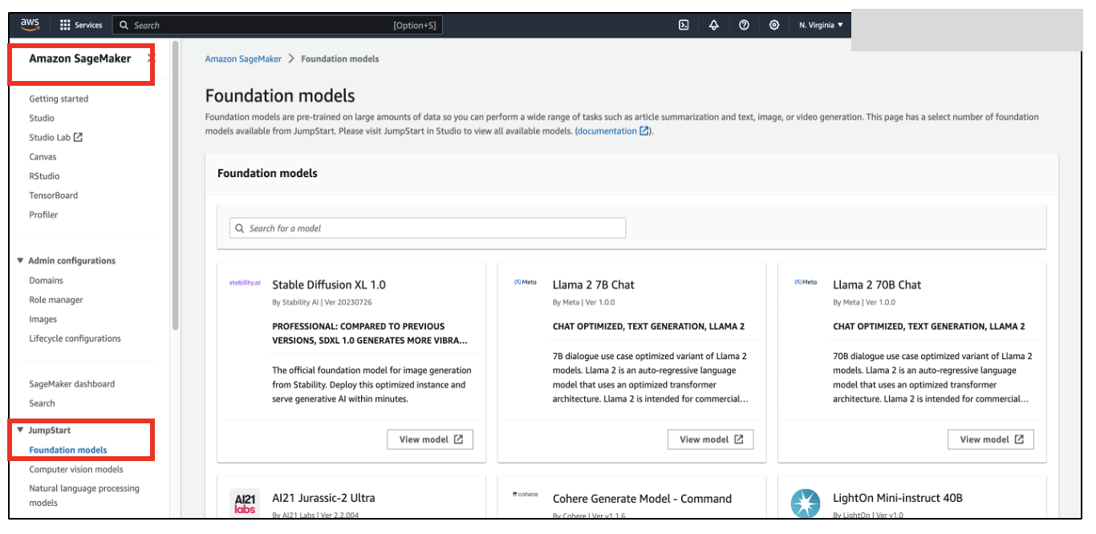

*Figure: 2-3 Amazon SageMaker Jumpstart at console*

Amazon SageMaker offers many features and tools. These innovations help organizations develop, train, and deploy advanced AI models quickly. This includes complex foundation models. They can do this at any scale.

As the ML landscape continues to evolve, AWS remains committed to driving innovation in Amazon SageMaker, ensuring customers have access to the most powerful and comprehensive platform for their AI and ML initiatives. (Refer <https://aws.amazon.com/pm/sagemaker/>)

##### **Middle layer of the stack: Tools to build with LLM’s and other FMs**

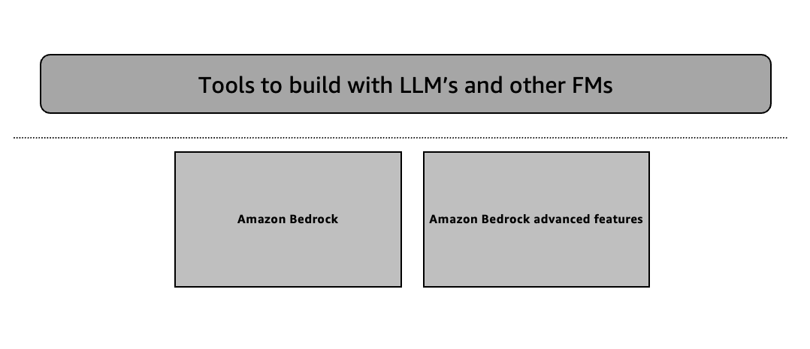

*Figure 2-4 Middle layer of the stack: Tools to build with LLM’s and other FMs*

However, you will drive deep into the details of this layer in the subsequent remaining chapters. But the middle layer of the AI stack offers large language models (LLMs) and other foundation models (FMs) as a service hosting on Amazon Bedrock. Amazon Bedrock offers customers access to top industry-leading models. You can customize these models with your own context of business information. This process is known as domain adaptation. You get the benefit from AWS features like strong security and access controls. Many industries are adapting Amazon Bedrock in rapid pace. Applications include chatbots, investment analysis, energy analytics, website creation, etc. You will learn many more use cases in this book. You will learn some of the solutions in the subsequent remaining chapters, along with some advanced features of Amazon Bedrock. Amazon Bedrock offers several key value propositions.

**Flexible Model Choice**: Amazon Bedrock hosts new models like Anthropic Claude, Meta Llama, Mistral, Cohere, Stability AI's Stable Diffusion, and many more from different model provider. Amazon's own Titan models (Titan Text Lite and Titan Text Express) are also available. your choice of model based on the use cases and for accuracy, performance, and cost. New models include Titan Multimodal Embeddings for multimodal search and Titan Image Generator for embedding and text-to-image generation, respectively. You will learn the depth and breadth of all the available models in the next chapter.

**Customization Capabilities**: Fine-tuning helps customers train models using their own data. This leads to more relevant and accurate responses. Retrieval Augmented Generation (RAG) lets models access data from proprietary sources. Continued pre-training helps models understand specific language and terminology for different fields. You will learn all these advanced techniques like pre-training (Chapter 10), fine-tuning (Chapter 10), and RAG architecture (Chapter 6) design patterns in the subsequent chapters.

**Agents for Multistep Tasks**: Agents can plan and execute multistep complex tasks across enterprise systems and data sources quickly with low development efforts. You can build and execute agents easily. You can also integrate agents with AWS Lambda and other features of Amazon Bedrock. You will learn more about Amazon Bedrock Agents in Chapter 9.

**Responsible AI Guardrails**: Guardrails allow customers to apply customized safeguards based on their use case requirements, industry, and responsible AI policies. This offers useful features like PII redaction and content filtering . These tools are helpful for various applications. In chapter 8, you'll learn about Amazon Bedrock Guardrails.

The platform is designed to be flexible, secure, and customisable. It helps customers build and scale their generative AI applications quickly.

##### **Top layer of the stack: Application that leverage LLM’s and other FMs**

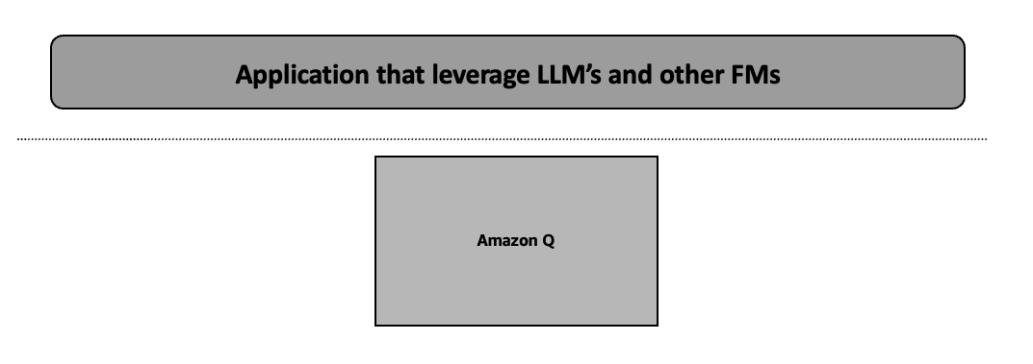

*Figure 2.5 Top layer of the stack: Application that leverage LLM’s and other FMs*

This layer talks about a couple of AI assistance applications leveraging generative AI. This layer brings great value, like accelerating software engineering and covering a variety of other use cases within the software engineering life cycle. You will learn an overview of Amazon Q below. Detail product information is out of scope of this book.

##### **Amazon Q**

Amazon Q offers two key functionalities, like Amazon Q Business and Amazon Q Developer. Amazon Q Business is designed for organizations. It helps them access information quickly and generate content easily. This tool boosts creativity and productivity. It connects data from more than 40 popular business tools with native connector. Even, you can develop custom connector based on your source system. It connects to corporate data sources. This allows organizations to find answers to various inquiries. It simplifies the process of accessing important information.

Amazon Q Developer is a powerful generative AI assistant designed to enhance software development and utilize internal company data. It can generate code, test, debug, and assist with complex planning tasks. This is a helpful tool for organization. It offers real-time code suggestions and automates tasks like upgrading Java applications from lower to latest version.

Amazon Q is a secure AI assistance tool. It prioritizes data privacy and security with high priority. It adheres to user permissions, hence ensuring trust in handling information and safeguarding customer data.

Amazon Q integrates with Amazon QuickSight, Amazon Connect, and Amazon Supply Chain. Its integration with QuickSight enables generative business intelligence. This makes data analysis and dashboard creation much easier. You can swiftly obtain insights, which boosts their business intelligence capabilities.

Overall, Amazon Q boosts productivity and streamlines workflows in business and software development. (Refer <https://aws.amazon.com/q/> )

# **2.2 Potential Industry Use Cases for Generative AI**

You explored the AWS Generative AI stack capabilities in the previous section. It is important to understand the profound impact this technology can have across a wide range of industries and use cases. Generative AI is transforming how businesses innovating and solving challenges in rapid pace. Its advancements are reshaping the mechanisms of problem-solving and idea generation.

The industry is observing the transformation of generative AI applications to boost productivity, enhance customer experiences, accelerate innovation, and unlock new business opportunities as organizations begin to harness the power of these area. Generative AI can have a significant positive impact on many industries. It can streamline and automate repetitive tasks, making processes more efficient. Furthermore, it may augment data analysis, resulting in enhanced decision-making for enterprises.

In the next chapter, you will examine some of the most intriguing and significant use cases for generative AI in important industries. Organizations use these foundation models to explore the unique issues and concerns each domain presents, drive observable business outcomes, and highlight the innovators who are redefining what is possible.

You will start to grasp just how transformative this technology can be when you delve into the myriad possibilities of generative AI and explore its vast potential. Nonetheless, you will learn with new ideas and strategic perspectives on how generative AI may transform numerous business facets to maintain a competitive edge and improve experiences for all stakeholders via some real-world case studies and examples included in this book. Additionally, you will learn creative applications of generative AI that help you obtain a competitive advantage and build closer relationships with business and customers.

Let's dive in and uncover the transformative power of generative AI in action.

The latest study by McKinsey & Company, you will explore generative AI use cases that will impact business functions differently across various industries.

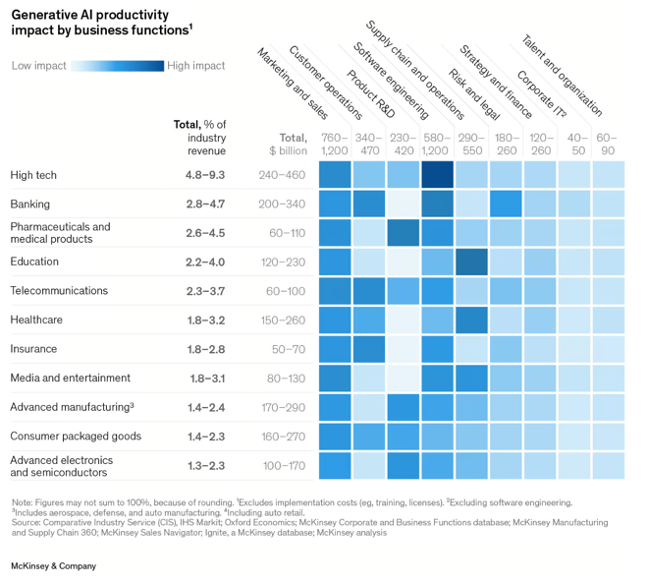

*Figure 2-6 Generative AI productivity impact by business functions - part 1*

Generative AI has the potential to generate value between $2.6 trillion and $4.4 trillion across a variety of industries. The specific magnitude of its impact will hinge on a multitude of factors, including the composition and significance of diverse functions, along with the scale of revenue within each industry like high tech, banking, life sciences, telecommunications, healthcare, insurance, etc. (Figure 2-6)

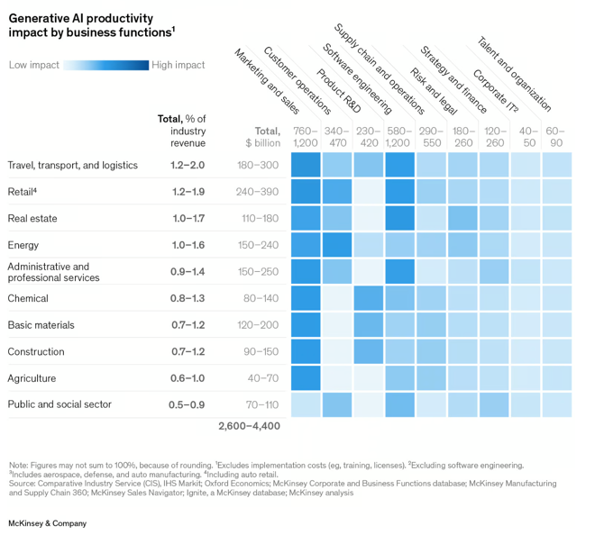

*Figure 2-7 Generative AI productivity impact by business functions - part 2*

Even there are numerous pertinent use cases in the retail, energy, public, and social sectors, as well as travel, transportation, and logistics. (Figure 2-7)

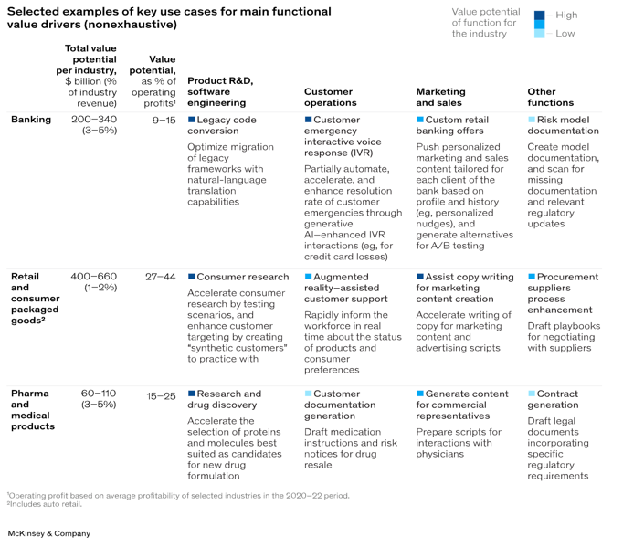

*Figure 2-8 Use cases for main functional value driver*

**Note: The sources for Figures 2-6, 2-7, and 2-8 are available at** [**https://www.mckinsey.com/capabilities/mckinsey-digital/our-insights/the-economic-potential-of-generative-ai-the-next-productivity-frontier#industry-impacts**](https://www.mckinsey.com/capabilities/mckinsey-digital/our-insights/the-economic-potential-of-generative-ai-the-next-productivity-frontier#industry-impacts)

McKinsey's analysis suggests that generative AI could add approximately $310 billion in added value to the retail industry (including auto dealerships) in areas like marketing and customer interactions. Even the primary source of potential value in the high-tech sector stems from generative AI's capability to expedite and streamline software development processes.

Generative AI also has the potential to improve the efficiencies that artificial intelligence has already achieved in the banking industry by taking on low-value risk management tasks like those in the areas of reporting, regulatory monitoring, and data collection. Even, generative AI also has the potential to significantly advance drug discovery and development efforts in the life sciences sector. (Figure 2-8)

# **2.3 Why Generative AI on AWS**

There are several reasons why organizations are thinking about partnering with AWS for generative AI. Here are a few of the most important points to consider.

* **Elasticity**: AWS offers elastic resources that automatically adjust to varying workloads. For example, a media company using AWS for generative AI can effortlessly handle spikes in demand during peak viewing hours without manual intervention, ensuring seamless user experiences with best practices and design of the solution.
* **Scalability**: AWS provides scalable infrastructure. It allows businesses to expand their generative AI projects as needed. For example, an AWS-based e-commerce platform can effortlessly expand the image generation capabilities of its generative AI application to meet the needs of an expanding user base without sacrificing efficiency.
* **Cost efficiency**: Pay-as-you-go pricing strategy from AWS allows businesses to be more cost effective. For example, a startup experimenting with generative AI on AWS can keep costs low during development and scale resources as the project matures and gains traction. You will learn different cost driver and pricing calculation later in this book.
* **Reliability and availability**: The vast global data center network of AWS ensures excellent availability and dependability. For example, consider a healthcare company using AWS to develop generative AI applications. In the event of unforeseen disruptions, customers can rely on redundant infrastructure to maintain critical services and data availability.
* **Monitoring and observability**: AWS provides comprehensive monitoring and observability tools for efficient troubleshooting and performance tracking. For example, a gaming company might integrate with apps based on generative AI and AWS CloudWatch. AWS CloudWatch tracks GPU and memory utilization and other metrics.
* **Global reach**: The extensive global presence of AWS allows organizations to implement generative AI solutions in proximity to their intended audiences. A content distribution platform can utilize AWS's edge locations to provide tailored video recommendations produced by generative AI. You can access global content with minimal delay.
* **Managed services**: AWS offers managed services that help organizations minimize administrative tasks. So, you can concentrate on innovation. A financial institution using AWS for generative AI can utilize Amazon Bedrock to simplify model customization, which accelerates the launch of new solutions. This book will cover the topic of model customization in detail.
* **Increased flexibility and choice**: AWS offers a wide range of services and tools for building and deploying generative AI solutions. For example, a design agency can choose from various foundation models on Amazon Bedrock to enhance creative workflows and deliver compelling visual content to customers.
* **Enterprise-Grade security and governance capabilities**: AWS prioritizes security and compliance. It always provides robust security features and governance controls. For example, a government agency utilizing AWS for generative AI can ensure data privacy and regulatory compliance by implementing encryption and access controls using AWS Identity and Access Management (IAM).
* **State-of-the-art generative AI capabilities**: AWS is consistently advancing in the realm of generative AI. It provides access to advanced technologies and algorithms. For instance, AWS is persistently advancing in the areas of responsible AI, multi-model, and multi-agent capabilities tailored for specific customer use cases.
* **Optimized operational overhead**: AWS helps organizations lower operational overhead by offering managed services like Amazon Bedrock. AWS manages their infrastructure and services. This enables companies to focus on their main solution goals and functionality. For instance, a manufacturing company exploring AWS for generative AI can achieve optimal cost performance in terms of both IT maintenance costs and complexity. It helps you focus on creating solutions and encouraging innovation.
* **Strong history of continuous innovation**: AWS consistently demonstrates its commitment to innovation by regularly launching new features and services that address the changing needs of its customers. For instance, a retail organization utilizing AWS for Generative AI can take advantage of AWS's ongoing advancements to maintain a competitive edge and provide tailored shopping experiences enhanced by AI-generated suggestions with multi model capability.

Overall, using AWS for generative AI projects has many benefits, such as being able to grow as needed, being reliable, having a global reach, offering managed services, being secure, being flexible, having access to cutting-edge technologies, having low operational costs, and a history of constant innovation. This makes it a great choice for companies that want to get the most out of AI.

# **2.4 Accelerate Generative AI Applications building on AWS**

AWS enables organizations to accelerate their generative AI initiatives by providing a comprehensive suite of cloud services. AWS aims to make its products, services, and solutions more democratizing and demystifying. It will allow customers to accelerate the development of generative AI-based applications. In this book, some of the tools and technologies will help you build five generative AI-based applications. You will learn most of the Amazon Bedrock features in the subsequent chapter. On the other hand, the managed Jupiter notebook serves as an excellent tool for developing and exploring generative AI applications on Amazon SageMaker. You can use generative AI application development with Amazon Cloud9, a cloud-based IDE. You can also use Amazon CloudWatch and Amazon CloudTrail for extensive monitoring and observability features. Organizations must focus on data ingestion, engineering, management, governance, and specialized data storage capabilities. So, developing generative AI applications requires a comprehensive data foundation strategy. This is one of the top priorities for businesses. AWS enables a smooth native integration with data and analytics products to ensure seamless interoperability and platform synergy.

Organizations in a variety of industries can use AWS to leverage new heights of innovation, productivity, and competitive advantage in their generative AI applications.

# **2.5 Generative AI Project Life Cycle**

People, processes, and tools are important elements in the generative AI project lifecycle for several reasons:

* **People**: Generative AI is a new technology in the industry for most of the industry. The importance of having the right strategy by organizations to upskill resources with generative AI, cloud knowledge, and AI-ML knowledge. Organizations need to focus on the right capability building in technology as well as business to build intuitive applications for solving real-world business problems. Technology is moving too fast. For that reason, every organization should have a continuous learning and development program in this field.
* **Process**: Clear processes and workflows are essential for streamlining the lifecycles of generative AI projects. This also ensures it becomes more effective and has uniformity as well as repeatability across different projects. These include managing use cases, building a strong data foundation, choosing appropriate foundation models, developing model evaluation and interpretation plans, making decisions on application deployment, and establishing monitoring frameworks. Additionally, when there are clearly defined processes, members of the team work together and communicate better, which minimizes errors and accelerates development cycles.
* **Tools and technologies**: Different stages of the generative AI project require appropriate tools and technologies. This mainly consists of databases and data lakes as ways of storing information, but also frameworks and libraries for generative AI application development and deployment. In generative AI projects, version control is critical for code and models. It helps maintain productivity and scalability. Furthermore, managing complexity is important. This includes tracking experiments, deploying models, and monitoring the solution's performance.

Organizations can enhance their use of generative AI by effectively integrating people, processes, and tools. This approach manages the entire AI lifecycle, from generating ideas to deployment. It enables ongoing performance enhancements.

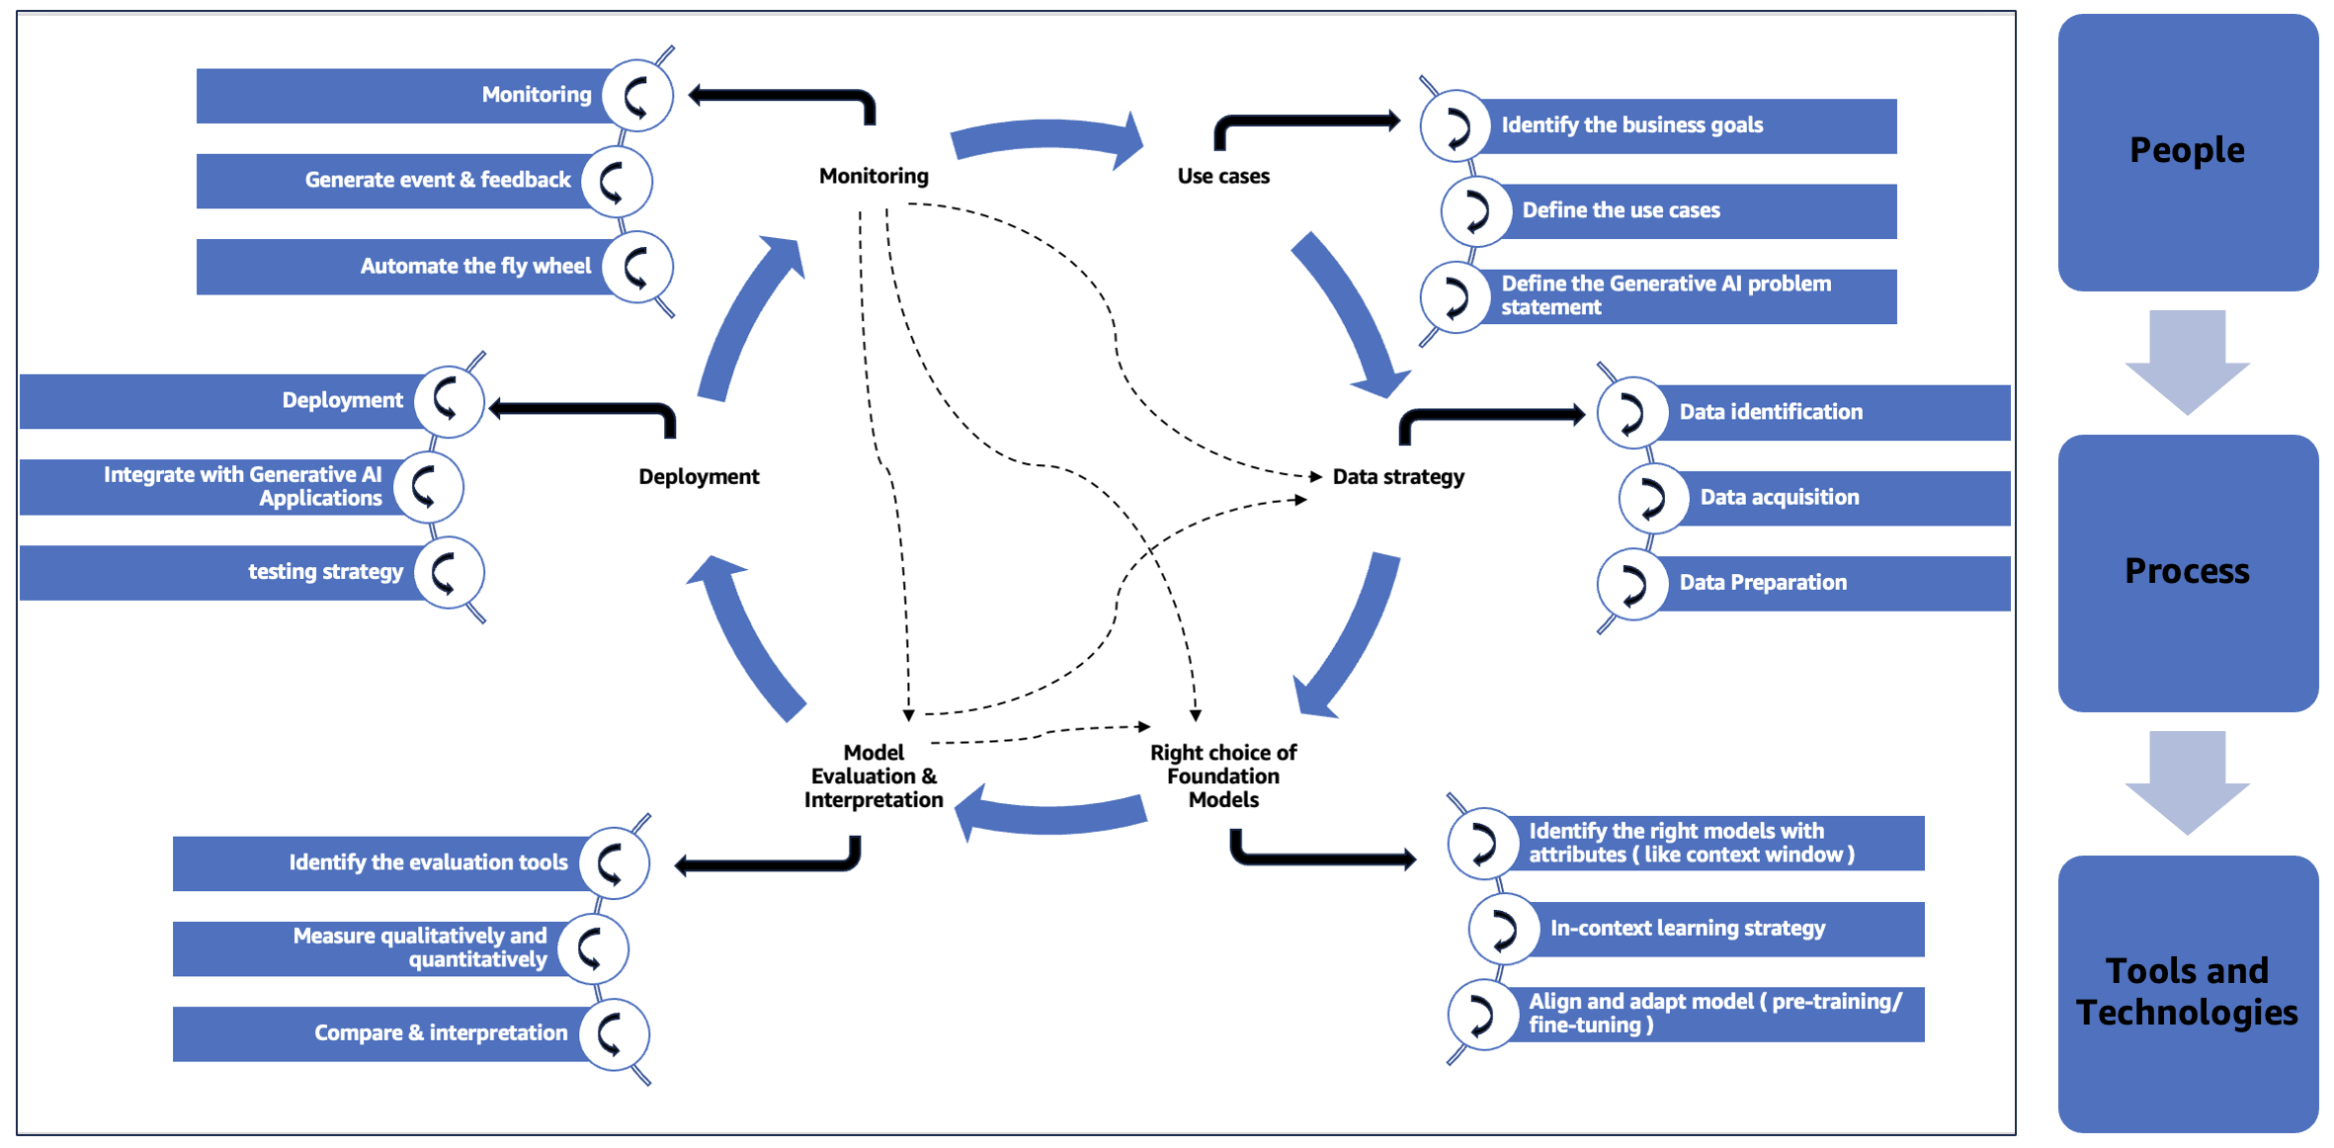

*Figure 2-9 Generative AI project lifecycle*

The following perspectives provide another crucial lens for understanding the generative AI project lifecycle.

* **Use cases**: Defining use cases plays an important role in the initial success of generative AI-based projects. Businesses can verify the true worth of the generative AI solution. The use cases for business understanding links well with the project goals to align with the overall strategy. It helps you set priorities and concentrate on main business objectives. It helps to achieve the desired outcome in business. Additionally, well-specified cases help in understanding target persona, problem domain, and specific requirements for the generative AI solution. It describes specific scenarios or applications where to leverage generative AI, including the end-user, the desired outcome, and the required functionality. Identifying its key elements, such as input data, desired output, constraints, and performance requirements, is very important to understand the problem. Furthermore, the detailed analysis of the use cases can help clarify these aspects. Sometimes, the problem statement specifies if the model requires customization, like fine-tuning or pre-training, or if other methods, like RAG or in-context learning, you will learn in detail about model customization and RAG in a subsequent chapter.
* **Data strategy**: A strong data strategy ensures that generative AI models train on high-quality, relevant data based on needs. Furthermore, it helps to enhance context with the right data at the right time with optimal latency and throughput. It enhances the performance and accuracy. Organizations can identify crucial data sources, types, and formats that are essential for achieving project objectives. Crucially, a data strategy shows how to effectively and safely buy required information in a way that complies with regulations and protects privacy. It is very significant because it helps identify masses of elaborate datasets needed for building strong generative AI models. Generative AI models require effective data management. This includes careful preparation steps to ensure output quality and maximize learning efficiency. A well-designed strategy enhances consistency and scalability, as well as making the reliability of model outcomes more effective by specifying duties such as data cleaning, normalization, and feature engineering.
* **Right choice of foundation models**: Choosing the appropriate foundation model is essential for generative AI projects. It affects the model's comprehension and production of contextually relevant outputs, including context window size. Equipped with the optimal foundation model tailored to the task, the AI system excels in capturing contextual details and producing high-quality outputs for diverse applications such as text generation and image captioning. The right choice of foundation models is crucial because it directly influences the generative AI solution's ability to quickly adapt to new tasks or domains through in-context learning. Certain foundation models excel in this capability, enabling streamlined project lifecycles by minimizing the time and resources needed for model adaptation and deployment.
* **Model evaluation and interpretation**: Model evaluation is very important for generative AI solutions followed by right interpretation of metrics. This involves a thorough qualitative and quantitative assessment. This book will teach you basic techniques for model evaluation. This process aligns with project goals and provides insights into model performance. Selecting appropriate evaluation tools enables businesses to make informed decisions, minimize risks, and enhance the effectiveness of their AI applications. Additionally, you will learn how to select the appropriate model for your specific use cases. Furthermore, model evaluation and interpretation are vital because it facilitates comparison to benchmarks and other models, aiding in identifying areas for improvement and making informed decisions about deployment. It also lends a hand in evaluating the model’s suitability for use cases, unearths possible biases, and informs adjustments to be made while refining the model during the project lifecycle.
* **Deployment**: The right deployment strategy is paramount since it helps make generative AI models accessible to end-users or other applications. Integration of generative AI with other applications and models is important if the model is to be part of big systems. Also, during deployment, a model should have a comprehensive testing strategy that guarantees that its functional, performance, and quality standards are met while also minimizing risks in operation. A lot of tests are done on the model to make sure it is reliable. This process improves the experience of you by finding and remediate problems before the launch. Testing the model repeatedly after release makes sure it meets business goals.
* **Monitoring**: For generative AI solutions to operate effectively and consistently, they must have robust monitoring and observability in place. This necessitates vigilantly monitoring early warning signs to promptly detect any anomalies within production and take appropriate action. Real-time events, as well as feedback loops stemming from anomalies or your inputs, eventually help to perfect them. It is clear that effective monitoring is pivotal in trustworthiness, automation, transparency, quick problem-solving processes, and progressive development.

People, process, and tools are all needed for the Generative AI project for successful execution. So, you learned the importance to get better at what you do, have organized processes, and have the right tools. It is very important to have clear data plans and carefully choose base models. Evaluation, implementation, and monitoring ensure solutions align with business goals. Continuous learning and effective communication enhance this process.

# **2.6 Summary**

The chapter provides an overview of the three layers AWS Generative AI stack. The infrastructure for training and inferring models is comprised of the bottom layer includes Amazon SageMaker, GPU instances, AWS Inferentia and Trainium chips, and Amazon EC2 UltraClusters. Amazon Bedrock is the main service used in the middle layer. Applications powered by generative AI, such as Amazon Q developer for AI-assisted coding and Amazon Q business for a conversational AI assistant, make up the top layer. This chapter highlights the key benefits of using AWS for Generative AI, including the elastic and scalable infrastructure, cost-efficiency, reliability, global reach, managed services, and state-of-the-art capabilities. It also explores the possible applications for industry such as high-tech, retail, banking and life sciences. Essential elements such as use case definition, data strategy, foundation model selection, model evaluation, deployment, and monitoring are covered in detail in a discussion of the Generative AI project lifecycle. This chapter concludes by highlighting how AWS offers a full range of cloud services, tools, and technologies to help enterprises develop cutting-edge applications, thereby accelerating their Generative AI initiatives.